**IDX G9 PHYSICS S STUDY GUIDE ISSUE 2**

**By Taeyun**

Uniformly accelerated motion: motion with constant acceleration

The Motion Formulas (reminder)

$a=\frac{Δv}{t}= \frac{v_{f}-v_{i}}{t}$

$Δd=d_{f}-d_{i}=\overline{v}×t=\frac{(v_{i}+v_{f})}{2}t$

$Δd=d_{f}-d_{i}=v_{i}t+\frac{1}{2}at^{2}$

$Δd=d_{f}-d_{i}=\frac{({v_{f}}^{2}-{v_{i}}^{2})}{2a}$

Free fall: motion of a falling object when air resistance is negligible and the only force is gravity

Galileo’s hypothesis: at a given location on Earth without air resistance, all objects fall with the same constant acceleration

Acceleration due to gravity, g = 9.8m/s2 towards earth’s center

Remember to either include direction at the end or define the directions before solving questions

**3.1 Vectors and Scalars**

Vector: magnitude and direction

Scalar: magnitude

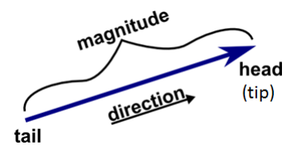Representing a vector:

1. A line and an arrow:
   1. Length: magnitude
   2. Direction: direction
   3. Symbol:
2. A diagram of a quadratic function

   Description automatically generatedDirections:
   1. Up “+”
   2. Down “–”
   3. Right “+”
   4. Left “–”
   5. Rectangular coordinates:

1. Drawing to scale
   1. Use ruler and compass to draw vectors
   2. Make a scale bar and follow that scale when drawing

**3.2 Addition of Vectors**

1. Tail-to-tip Method
   1. 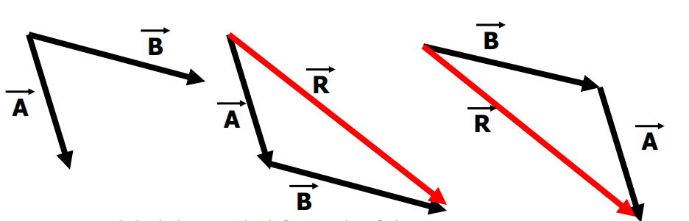Resultant/net: sum of two or more vectors
   2. Commutative: $\vec{A}+\vec{B}=\vec{B}+\vec{A}$
   3. How to find resultant/net:
      1. Move tail of a vector to the tip of another without changing magnitude or direction
      2. The resultant points from the tail of the first vector to the head of the last
   4. When vectors form a closed polygon, there is no resultant
2. Parallelogram Method
   1. Place 2 vectors tail-to-tail
   2. Draw a parallelogram with the vectors are sides
   3. 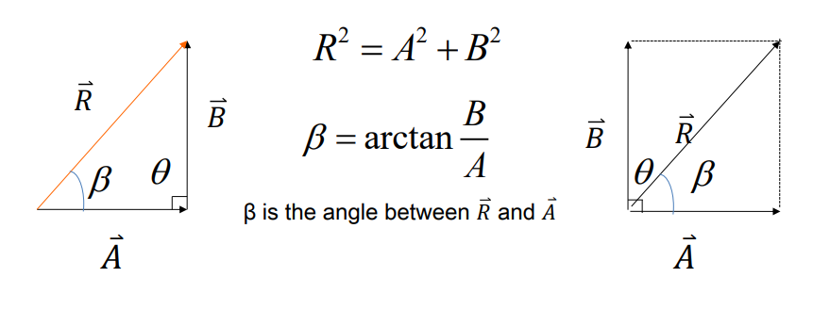Diagonal from common origin is resultant vector
3. Pythagorean Theorem
   1. Can be used to calculate magnitude and angle

**3.3 Subtraction of Vectors, and Multiplication of a Vector by a Scalar**

1. Subtracting vectors
   1. Negative Vectors
      1. Two vectors are negative if they have the same magnitude but opposite directions (A = –B)
      2. If we add a negative vector to another, it is subtracting (A – B = A + (–B))
   2. Multiply the vector
      1. A vector can be multiplied by a scalar *c*
         1. If *c* is positive, then *c $\vec{A}$* has the same direction and magnitude of *c*A
         2. If *c* is negative, then *c $\vec{A}$* has the opposite direction as $\vec{A}$ and a magnitude of *c*A

**3.4 Adding Vectors by Components**

1. Vector components:
   1. 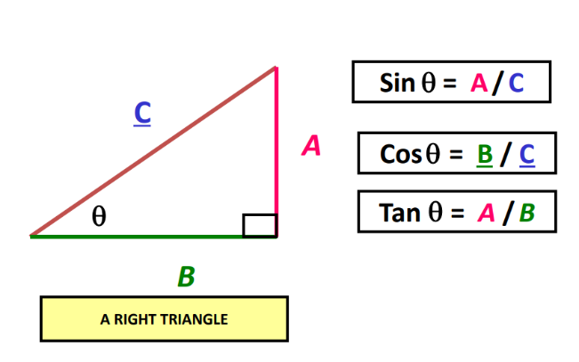Once you place a vector in a coordinate plane, it can be broken into components:
      1. $\vec{A}=\vec{A_{x}}+\vec{A_{y}}$ (x component, y component)
      2. This process is called vector resolution
   2. Fundamental Trigonometry:
   3. x and y components of a vector:
$\vec{A_{x}}=Acosθ$

$\vec{A_{y}}=Asinθ$

${A_{x}}^{2}+{A_{y}}^{2}=A^{2}$

$θ=\tan^{-1}{(\frac{R_{y}}{R_{x}})}$

2. Adding vectors using components
   1. Steps:
      1. Resolve each vector into its x and y components
      2. Adding the x components of all the vectors
      3. Adding the y components of all the vectors
      4. Get the resultant with the Pythagorean theorem

**3.5 Projectile Motion**

1. Concepts of Projectile Motion
   1. Projectile: an object shot through the air
   2. Trajectory: the curved flight path that is followed by a moving object
   3. Ignoring air resistance, the net force on an object after it’s launched is gravity
   4. Projectile motion is a combination of two independent motions
      1. Horizontal motion: constant velocity when no air resistance
      2. Vertical motion: constant acceleration
2. Projectile launched horizontally
   1. No initial vertical velocity
      1. Analyze the horizontal and vertical motion separately
         1. Horizontal Motion: constant v (range: $d_{x}=v_{ix}t$)
         2. Vertical motion: free fall (height: $d_{y}=\frac{gt^{2}}{2}$)
      2. Velocity vector at each instant is always tangent to parabola
      3. The horizontal and vertical motion are independent
         1. Time from launch to hit the target is the same for both motions
      4. What affects the range?
         1. Horizontal velocity
         2. Flight time
3. Projectile launched at an angle
   1. Separated motion diagram
      1. Initial velocity $v_{i}$:
         1. $v_{ix}=v_{i}cosθ_{i}$: x component/horizontal
         2. $v_{iy}=v_{i}sinθ_{i}$: y component/vertical
      2. Maximum height ($h_{max}$): height of projectile when $v_{y}=0$
      3. Level horizontal range (R): horizontal distance projectile travels before returning to initial height
      4. Flight time/hang time: how long the projectile is in the air
      5. Equations to use:

$h_{max}=\frac{{v_{iy}}^{2}}{2g}$

$t_{highest}=\frac{V_{iy}}{g}$

$t_{flight}=2\frac{V_{iy}}{g}$

$R=v_{ix}t_{flight}=\frac{{V_{i}}^{2}sin2θ_{i}}{g}$

**3.8 Relative Velocity**

Relative velocity: The velocity of one body relative to another

Formulas:

* 1. **Force**

1. Basic Idea of Force
   1. Force: a push or pull exerted by one object on another (vector)
   2. Interaction between 2 objects:
      1. System: to whom the force is exerted
      2. Agent: by whom the force is exerted
   3. The effect of a force
      1. A deformation (change in dimension or shape)
      2. Change in state of motion (change velocity)
   4. Unit: Newton(N)
      1. 1N = 1kg m/s2
   5. Measurement device: spring scale
   6. Three factors of forces:
      1. Magnitude: the strength of the force vector
      2. Direction: in which direction the force vector acts
      3. Point of application: the location the force is exerted
   7. Graphical Representation
      1. Vector
2. Different Types of Forces
   1. Four fundamental forces
      1. Gravity force
      2. Electromagnetic force
      3. Strong force
      4. Weak force
3. Contact forces and Field forces
   1. Contact force: force exerted through contact
      1. Friction ($F_{f}$)
      2. Drag force (air resistance/fluid resistance)
      3. Tension ($F_{T}$)
      4. Normal force ($F_{N}$)
      5. Spring force ($F_{sp}$)
      6. Applied force ($F_{App}$)
   2. Field force: force exerted without contact
4. Spring force
   1. Hooke’s Law:
      1. The magnitude of the force is directly proportional to the amount of stretch or compression within the limit of a spring
      2. Spring becomes deformed if it is stretched beyond limit
      3. 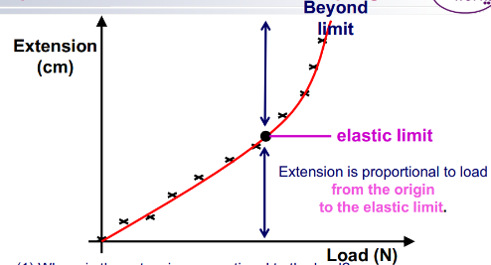Formula: $F_{sp}=-kx$
         1. $F_{sp}$: force exerted by spring on attached object(N)
         2. $x$: displacement from spring end from its equilibrium position(cm)
         3. $k$: spring constant(N/cm)
5. Friction
   1. Types of friction
      1. Sliding friction: friction from sliding
         1. Static friction ($F_{fs})$: caused by tendency of no relative motion
         2. Kinetic friction ($F_{fk})$: caused by relative motion
      2. Rolling friction: friction from rolling
      3. Fluid friction: friction when moving through a fluid
   2. Magnitude of Friction
      1. Static Friction: same as force causing relative motion
 $F_{fs}=F_{cause}$

        1. Static friction has a range $(0<F_{fs}≤F_{fsmax})$

 $F_{fsmax}=μ_{s}F_{N}$

 $μ_{s}$          2. : static friction coefficient
      2. 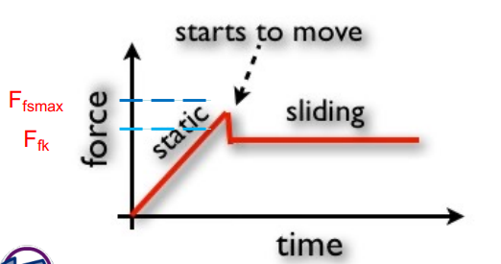Kinetic Friction
         1. Same objects: $F_{fk}≤F_{fsmax}$
 $F_{fk}=μ_{k}F_{N}$

 $μ_{k}$       2. : kinetic friction coefficient
6. Air resistance depends on
   1. Shape: streamline: reduce friction
   2. Size: surface area ↑ $F_{air}↑$
   3. Speed ↑ $F_{air}↑$
   4. Fluid type: viscosity $↑F_{air}↑$
7. Combining Forces
   1. Vector addition
8. Balanced forces
   1. Equilibrant and balanced forces when:
      1. Two different forces acting on the same object (same point of application)
         1. With same magnitude
         2. Opposite directions
         3. Acts on same line
   2. Equilibrium (when objects experience balanced forces)
      1. At rest
      2. Uniform motion
      3. Net force = 0
   3. Unbalanced forces: net force ≠ 0 (unbalanced forces changed object’s motion)
      1. Starts moving
      2. Stops moving
      3. Changed direction
9. Free Body Diagram: physical model that represents all the forces on the system
   1. Draw:
      1. System
      2. All forces labeled
   2. **Newton's First Law of Motion (aka Law of Inertia)**
10. Every object continues in its state of rest, or of uniform velocity in a straight line, as long as no net force acts of it
11. Inertia: tendency of an object to maintain its state of rest or of uniform motion in a straight line
12. Remember:
    1. Inertia is not a force
    2. Larger mass large inertia
13. Inertial Reference Frames:
    * 1. Inertial Reference frames: reference frames in which Newton’s first law does hold
      2. Non inertial reference frames: reference frames in which Newton’s first law does not hold
    1. **Mass**

Newton said: mass is a quantity of matter

1. Inertial Mass: mass is equal to the ratio of the net force exerted on an object to its acceleration
   1. Mass is a measure of inertia of an object
$m_{inertial}=\frac{F_{net}}{a}$

2. Gravitational mass: mass as used in the law of universal gravitation determines the size of the gravitational force between two objects
$m_{grav}=G\frac{Mm}{r^{2}}$

3. Principle of Equivalence
   1. Newton said: intertial mass and gravitational mass are equal in magnitude
   2. **Newton’s Second Law of Motion**
4. The acceleration of an object is directly proportional to the net force acting on it, and is inversely proportional to its mass. The direction of the acceleration is in the direction of the net force acting on the object
$\vec{a}=\frac{\sum{\vec{F}}}{m}$

5. Apparent weight: force exerted by the scale
   1. A spring scale measures weight, not mass
   2. Suppose you are standing on a scale in an elevator
      1. The elevator is in equilibrium
 $F_{sp}=F_{g}$

     2. The elevator accelerates upward
 $F_{net}=ma≠0$

 $F_{net}=F_{sp}-F_{g}$

 $F_{sp}=F_{g}+F_{net}=mg+ma=m\left(g+a\right)$

 $F_{sp}>F_{g}$

  3. The elevator accelerates downwards
 $F_{net}=ma≠0$

 $F_{net}=F_{g}-F_{sp}$

 $F_{sp}=F_{g}-F_{net}=mg-ma=m\left(g-a\right)$

 $F_{sp}<F_{g}$

  4. The elevator is in free fall
 $F_{net}=ma=mg$

 $F_{net}=F_{g}-F_{sp}$

 $F_{sp}=F_{g}-F_{net}=mg-ma=m\left(g-a\right)$

$F_{sp}=0$

3. **Newton’s Third Law of Motion**
   4. **Weight – the force of gravity; and the normal force**